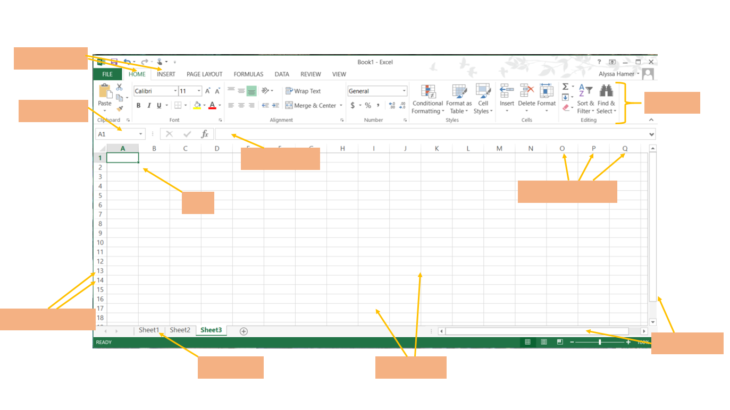 Fill in the names of the spreadsheet components, using the Spreadsheet Vocabulary provided.

Row numbers

Ribbon

Menu bars

Column letters

name

Sheet tab

Grid Lines

Scroll bar

Formula bar

Cell

**Row Numbers x**

Horizontal references in a spreadsheet; identified by a number.

**Column Letters x**

Vertical references in a spreadsheet; identified by an alphabetic letter.

**Cell**

A cell is an intersection of a column and row. Each cell has a unique cell address.

**Name Box x**

This shows the address of the current selection or active cell.

**Formula Bar x**

The formula bar displays information entered—or being entered as you type—in the current or active cell.

**Sheet Tab x**

A worksheet is a grid of cells consisting of rows and columns. Spreadsheet information—text, numbers, or mathematical formulas—is entered into different cells.

**Menu Bars x**

The menu bars displays all of the menus available for use in Excel. The contents of any menu can be displayed by left-clicking the menu name.

**Ribbon x**

Displays commands that are available for the selected Menu Bar item. Some commands in the ribbon have pictures or icons associated with them.

**Scroll Bars x**

The vertical scroll bar is used to move up or down the spreadsheet. The horizontal scroll is used to move left or right across the spreadsheet.

**Grid Lines x**

The horizontal and vertical lines in a spreadsheet.